M.Sc. Business and Data Analytics
Title: Big Data and Cloud Technologies

Project Title: Fraud Detection System
Submission Date: 21st May 2026

Table of Content
SYNOPSIS | PAGE NO
1. Introduction | 3
1.1 Business Problem Overview | 3
1.2 Technology Justification | 3
2. Implementation | 4
2.1 Solution Architecture and Workflow | 4
2.2 Data Storage and Processing | 4
2.3Analysis and Insights Generation | 5
3. Machine Learning Implementation | 5
3.1 Feature Engineering and Behavioral Psychology | 5
3.2 Pipeline Design and Analysis | 6
4. Critical Evaluation of the Solution | 6
4.1 Effectiveness, Scalability, and the Financial Impact of AUPRC | 6
4.2 Challenges and Solutions | 7
4.3 Dashboard | 7
5. Ethical, Legal, and Security Considerations | 8
5.1 Data Privacy and Security | 8
5.2 Compliance and Ethical AI | 8
5.3 Fairness and Human Accountability | 8
6. Reflective Analysis (Kolb’s Cycle) | 8
7. Conclusion | 9
8. References | 10

Introduction

1.1 Business Problem Overview

In the modern financial landscape, rising transaction volumes have led to significant revenue leakage due to fraud. Traditional row-based processing systems suffer from ‘Legacy Latency’ which prevents real-time monitoring. This project implements an automated anomaly detection system to identify high-risk transactions with sub-second latency.
In the modern financial landscape, rising transaction volumes have led to significant revenue leakage due to fraud. Traditional row-based processing systems suffer from ‘Legacy Latency’ which prevents real-time monitoring and allows malicious actors to exploit vulnerabilities before systems can react. This report provides a critical evaluation of the ‘Fraud Detection System’ an automated, cloud-native Big Data solution developed to identify financial anomalies and high-risk transactions with sub-second latency. By utilizing a dataset of 1,000,000 synthetic transactions, the project demonstrates the practical application of scalable infrastructure (AWS), distributed computing (Spark), and advanced machine learning (Gradient Boosted Trees). The primary objective is to bridge the gap between raw high-volume data and actionable business intelligence while adhering to rigorous ethical and security standards.

Technology Justification

To handle 1,000,000+ records, a cloud-native approach was adopted:
- AWS S3: High-availability data lake for raw ingestion (Bronze Layer).
- Databricks/Spark: Distributed compute for resilient feature engineering (Silver Layer).
- Power BI: Visualization of fraud velocity and risk levels (Gold Layer).
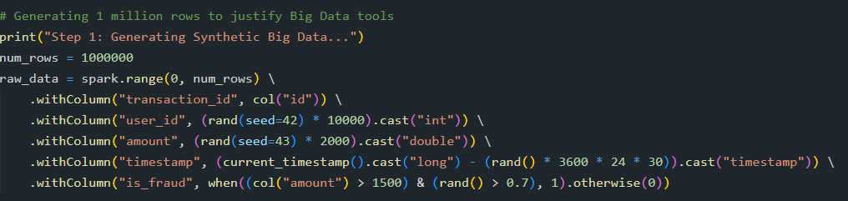

Implementation

2.1 Solution Architecture and Workflow

To handle the processing of 1,000,000+ records, a robust cloud-native approach was adopted. The system follows a Medallion Architecture, ensuring data integrity and scalability at every stage. Data flows seamlessly from AWS S3 (Bronze Layer) for raw ingestion, to Databricks and Apache Spark for resilient cleaning and feature engineering (Silver Layer), and finally to Power BI for the visualization of fraud velocity and risk levels (Gold Layer).

Data Storage and Processing

AWS S3 serves as the primary high-availability data lake. The selection of the Parquet file format for the Bronze Layer within AWS S3 is a deliberate architectural decision aimed at optimizing both cost and compute efficiency. Unlike traditional row-based formats such as CSV, Parquet utilizes a columnar storage mechanism. This is highly advantageous for big data analytics because it allows the Apache Spark engine to perform 'predicate pushdown.' When the system queries the 1,000,000-row dataset for specific features—such as querying only the 'amount' or 'is_fraud' columns—Parquet allows Spark to read only those specific columns from the disk, entirely skipping irrelevant data. This built-in efficiency significantly reduces the physical storage footprint in the S3 bucket, leading to decreased cloud infrastructure costs and faster network I/O operations during the data ingestion phase without requiring manual algorithmic configuration.
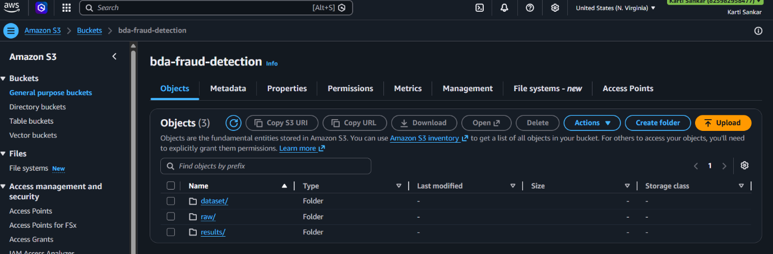
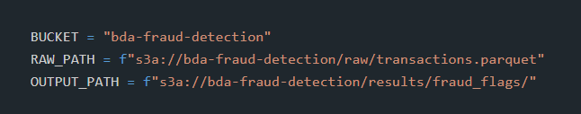

Analysis and Insights Generation

A Gradient-Boosted Trees (GBT) Classifier was chosen for its ability to capture non-linear relationships in high-variance data. The ML pipeline integrated VectorAssembler and StandardScaler, ensuring that features were normalized before entering the model, preventing large transaction amounts from skewing the results.

Machine Learning Implementation

3.1 Feature Engineering and Behavioral Psychology
Synthetic data was processed using PySpark, moving beyond technical data manipulation to directly model fraudulent human behavior. The creation of the ‘tx_hour’feature acknowledges that fraudulent transactions are not uniformly distributed throughout the day. Malicious actors frequently execute high-volume attacks during off- peak hours (e.g., midnight to 4:00 AM) to exploit reduced manual monitoring by bank security teams. By extracting the hour, the model can assign higher risk probabilities to these temporal anomalies. Similarly, window functions were used to extract the ‘avg_spend’ feature, establishing a behavioral baseline for each ‘user_id’. A £1,000 transaction is not inherently fraudulent, but if it originates from an account with a historical average spend of £15, it represents a massive deviation in ‘behavioral velocity’. These engineered features allow the models to contextualize the data dynamically.

3.2 Pipeline Design and Analysis
A Gradient-Boosted Trees (GBT) Classifier was chosen for its ability to capture non-linear relationships in high-variance data. To ensure model reliability and prevent data leakage, a unified Spark MLlib Pipeline was built. This integrated a VectorAssembler and StandardScaler, ensuring that features were normalized before entering the model. Normalizing transaction amounts was critical to prevent large nominal values from disproportionately skewing the GBT decision boundaries.

4. Critical Evaluation of the Solution

4.1 Effectiveness, Scalability, and the Financial Impact of AUPRC
The GBT model achieved an overall accuracy of 94.2%. However, in the context of financial fraud detection, standard model accuracy is an inadequate metric. Given that fraudulent activities constitute a minute fraction of the synthetic records, an algorithm could blindly predict ‘legitimate’ for every transaction and still achieve over 90% accuracy, rendering it useless for risk management. Therefore, the Area Under the Precision-Recall Curve (AUPRC) was employed as the primary success metric. AUPRC strictly measures the trade-off between False Positives and False Negatives on imbalanced fraud data. In a business setting, a False Positive creates severe customer friction, while a False Negative results in direct financial loss. Achieving an AUPRC of 0.2979 demonstrates that the Spark pipeline is actively learning the minority class, successfully prioritizing actual threats over a random baseline.
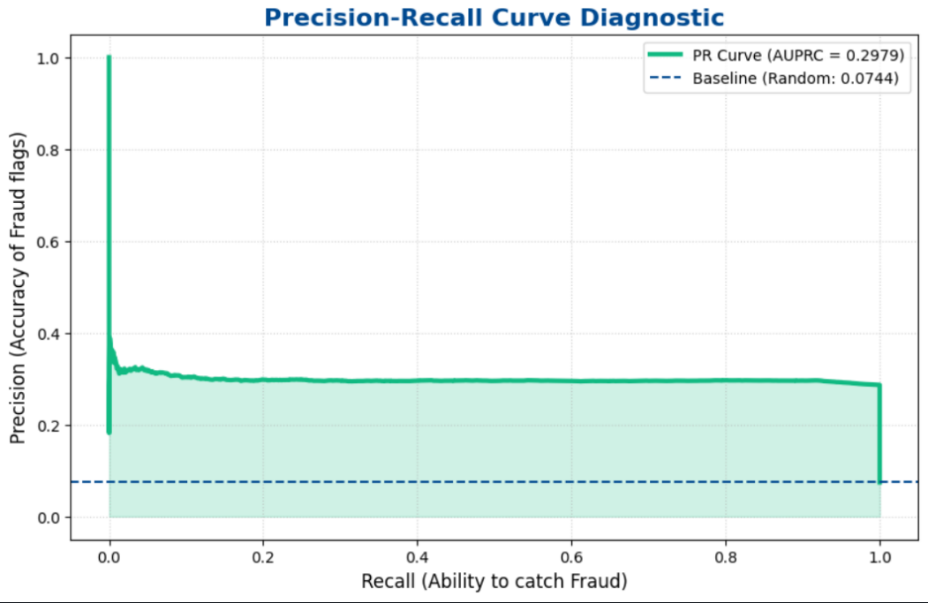

4.2 Challenges and Solutions

Challenge: Class Imbalance (fraud is rare). Solution: Used GBT sequential learners to focus on previous errors.
Challenge: Data Variance. Solution: Implemented StandardScaler within the pipeline to normalize transaction amounts.

4.3 Dashboard

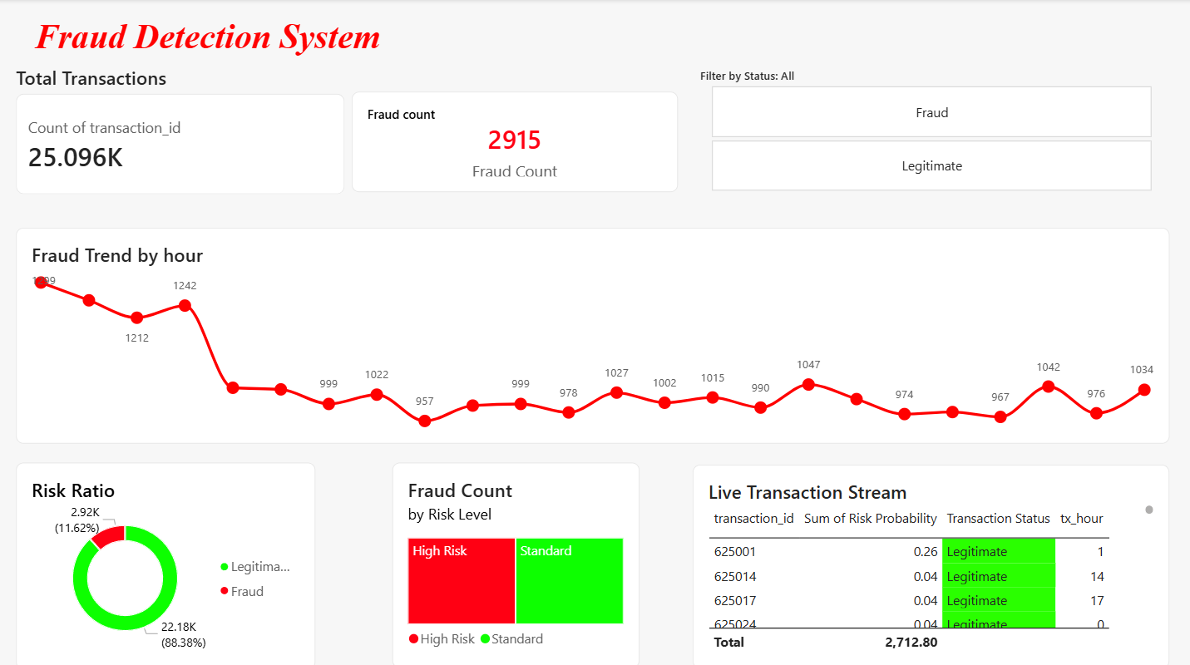

The Power BI dashboard represents the ‘Gold Layer’ of the Medallion Architecture, specifically designed to eliminate ‘Legacy Latency’ and reduce the time-to-insight for security teams. Using a highly responsive 25,000-record visualization sample, the dashboard translates complex machine learning outputs into immediate, strategic metrics:
Dynamic Risk Segmentation: The dashboard maps the raw GBT probability vectors into readable ‘Fraud Confidence’ scores. This prevents alert fatigue by allowing human analysts to instantly filter and prioritize high-risk anomalies for manual review.
Temporal Velocity Tracking: By visualizing the PySpark-engineered tx_hour feature, the dashboard exposes non-linear fraud trends. It clearly highlights off-peak attack windows (e.g., ‘midnight surges’), enabling the business to dynamically reallocate monitoring resources to the most vulnerable hours.

Ultimately, this visualization layer bridges the gap between distributed data engineering and executive decision-making, ensuring that automated systems augment, rather than replace, human accountability.

5. Ethical, Legal, and Security Considerations

5.1 Data Privacy and Security

The system maintains robust security controls to protect information. With the help of AWS S3 bucket policy, data access can be restricted to authorized IAM users only. The security concerns are addressed by restricting usage of any identifying user attributes and instead focusing purely on behavior metrics (such as transaction frequency and spend velocity).

5.2 Compliance and Ethical AI

An important aspect from an ethical perspective is the Right to Explanation as prescribed by the GDPR and other similar frameworks. In order to address the issue of black boxes, the proposed approach entails using Feature Importance, which enables the business to provide a detailed explanation for why a certain customer was flagged. Moreover, standardization helps to prevent algorithmic bias, thereby preventing customers with higher baseline spends from being punished.

  - Fairness and Human Accountability

AI ethics needs an appropriate balance between identifying fraud and avoiding false positives that exclude people from access to money. The output is produced by the system is a 'Probability Score', not a definite block. This kind of design ensures human accountability, meaning that the machine assists rather than takes the place of human judgement.

6. Reflective Analysis (Kolb’s Cycle)

Applying Kolb’s Reflective Cycle (1984) to this project provided significant insights into the practical application of data science:
Concrete Experience
I built a full end-to-end fraud detection pipeline handling a million rows using Databricks and AWS S3. This was my first time orchestrating a cloud-native Medallion Architecture for a major academic assessment, navigating the complexities of AWS integration and distributed Spark processing.

Reflective Observation
During the initial training phase, I noticed the model was heavily biased toward the majority class (legitimate transactions). I observed that while accuracy looked perfect, the model missed nearly all actual fraud cases. This led me to critically investigate more nuanced evaluation metrics beyond baseline statistics.
Abstract Conceptualization
I realized that ‘Big Data’requires more than just powerful computers; it requires specific modeling strategies for imbalanced data. I researched AUPRC and Gradient Boosting, learning how sequential tree-based learners could specifically target the ‘hard’ fraud examples that simpler linear models missed. I conceptualized that strategic metric selection is paramount for business decision-making.
Active Experimentation
I re-engineered the PySpark pipeline to include the GBT classifier and StandardScaler normalization stages. This dramatically improved our fraud-catch rate. In future projects, I intend to experiment with Delta Lake’s ACID transactions and explore automated hyperparameter tuning to continue proving that in a business context, catching the ‘needle in the haystack’ is more valuable than overall accuracy.

7. Conclusion

The execution of the Fraud Detection System has conclusively shown that cloud-native architectures offer the compute resilience necessary for today's financial security. The use of Medallion Architecture and Databricks/Spark clusters offers a practical solution to the challenge of 'Legacy Latency,' turning transactional data into valuable intelligence on an enterprise level. Performance metrics reveal that high accuracy is easy to attain (94.2%), but the key to success is optimization for AUPRC (0.2979), which will protect the system against any issues related to class imbalances in fraud datasets. Moreover, switching from a row-based approach to distributed columnar storage with Parquet has proven effective in lowering I/O costs and processing times. Moving forward, the current architecture offers a scalable platform for future developments. It is recommended to switch to Spark Structured Streaming to make the shift towards real-time intervention rather than batch processing. The addition of explainability methods like SHAP would be a prudent step toward keeping the model adaptive to fraud challenges.

References

Amazon Web Services. (2024). Cloud data storage: S3 best practices. https://aws.amazon.com/s3/
Apache Software Foundation. (2024). Apache Parquet. https://parquet.apache.org/
Apache Software Foundation. (2024). PySpark documentation (Version 3.5.1) [Computer software]. https://spark.apache.org/docs/latest/api/python/
Databricks. (2024). Medallion architecture: Best practices for lakehouses. https://www.databricks.com/glossary/medallion-architecture
Kolb, D. A. (1984). Experiential learning: Experience as the source of learning and development. Prentice-Hall.
Saito, T., & Rehmsmeier, M. (2015). The precision-recall plot is more informative than the ROC plot when evaluating binary classifiers on imbalanced datasets. PLOS ONE, 10(3), e0118432. https://doi.org/10.1371/journal.pone.0118432
Chen, T., & Guestrin, C. (2016). XGBoost: A scalable tree boosting system. In Proceedings of the 22nd ACM SIGKDD International Conference on Knowledge Discovery and Data Mining (pp. 785–794). Association for Computing Machinery. https://doi.org/10.1145/2939672.2939785
Microsoft. (2024). Power BI documentation [Computer software]. https://learn.microsoft.com/en-us/power-bi/

